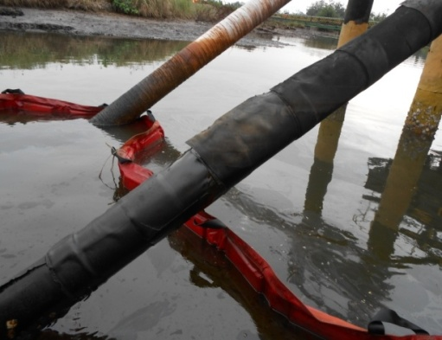
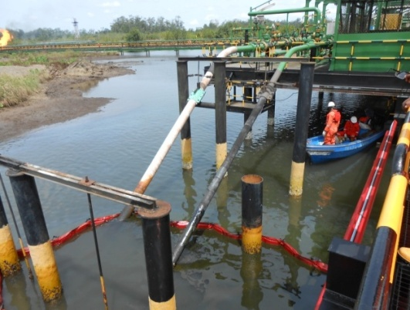
DOCUMENTATION/STILL PHOTOGRAPHS OF SITE

BOOM

FIG 1- OVERVIEW PICTURE OF THE SITE/SPOT FIG 2- THE CORRODED FACILITY
(BEFORE EXPOSURE)
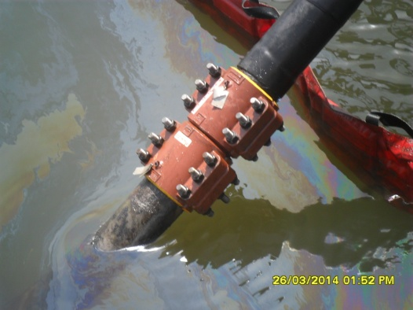
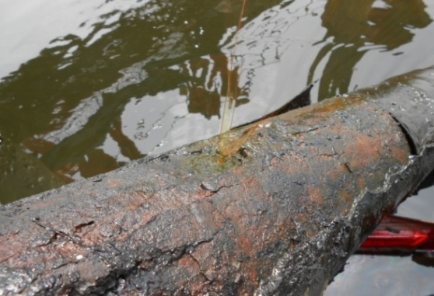

FIG 3- SPILL POINT (AFTER BEING EXPOSED) FIG 4- REPAIRED POINT

