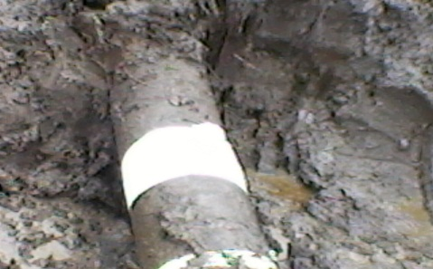
REPAIRED POINT
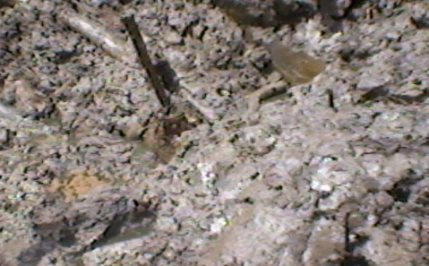
SPILL POINT BEFORE EXCAVATION

