6.0 PHOTOGRAPHS TAKEN DURING THE JIV EXERCISE

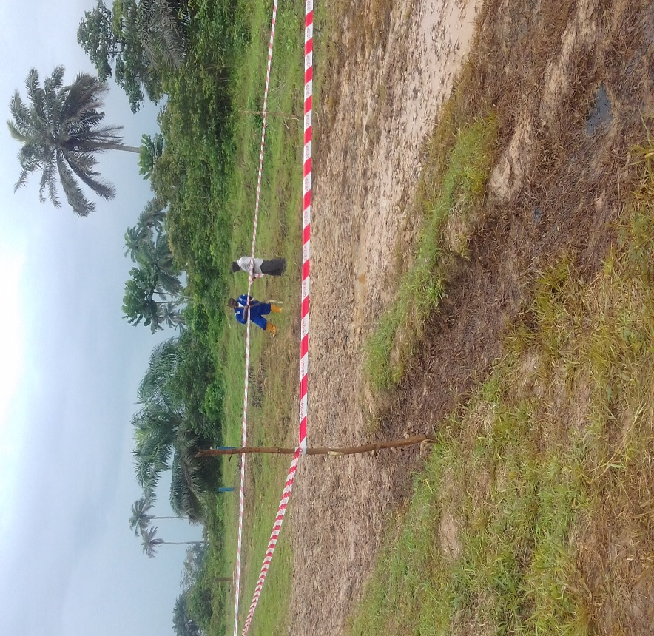
Flow line spill point demarcated before excavation

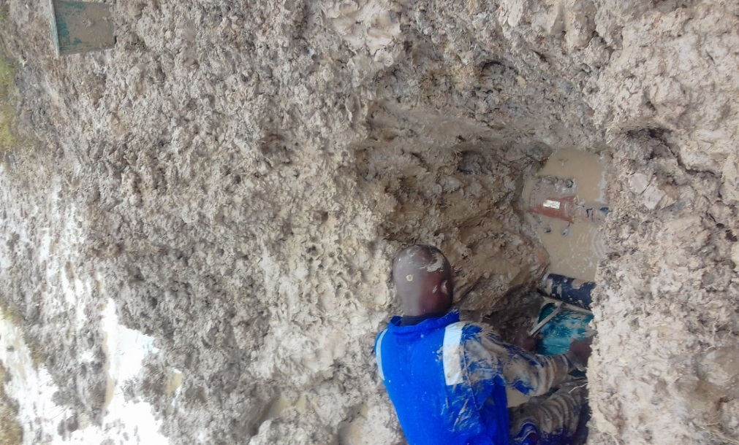
Digger bailing out water and clay soil to expose flow line

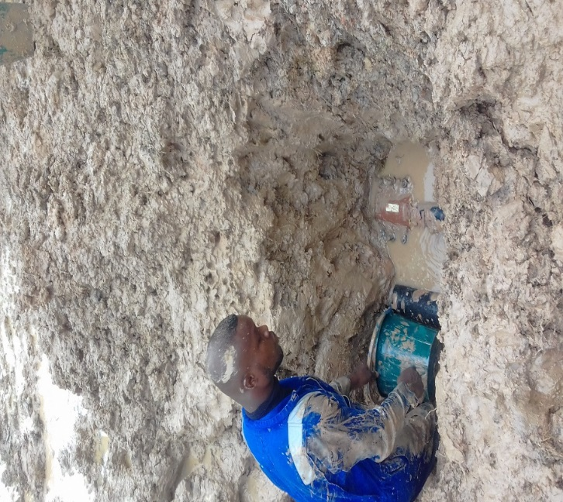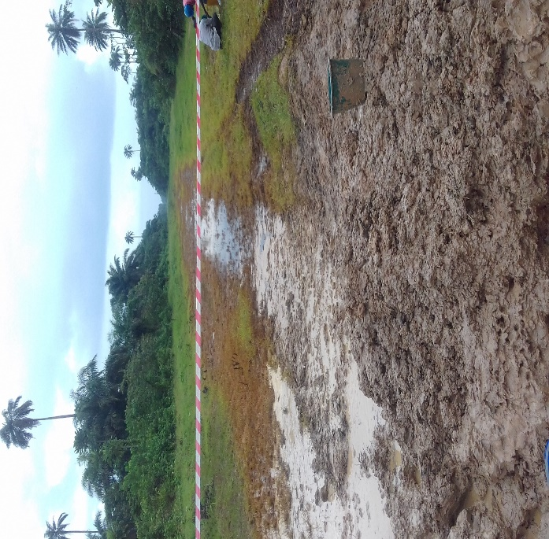
Exposed clamp (brown) on 6^{II} Flow line Spill impact area within Flow line ROW

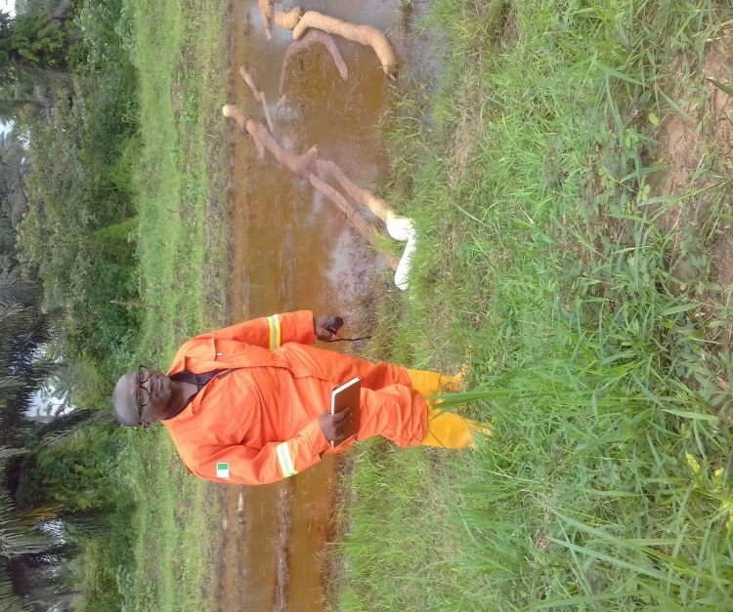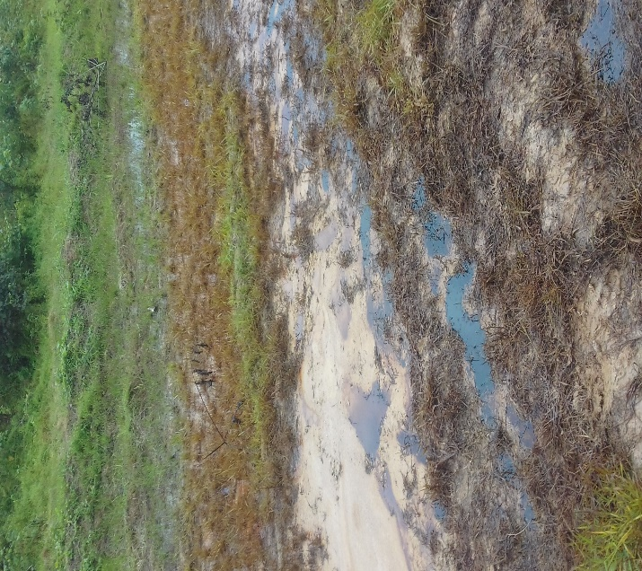
Mr Obot beside absorbent boom on
Pockets of oiling within ROW

surface water in Flowline ROW

