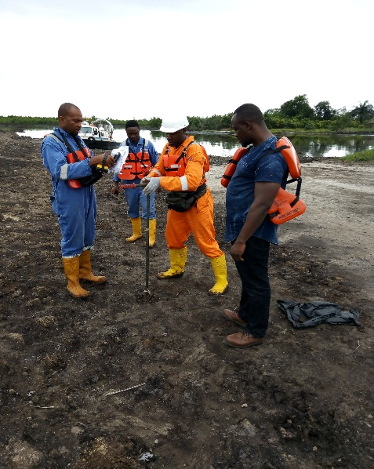
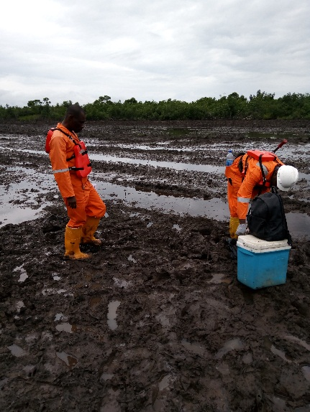

CLEANUP SITE AT WELL 41S AT SAND SAND KALABARI COMMUNITY

