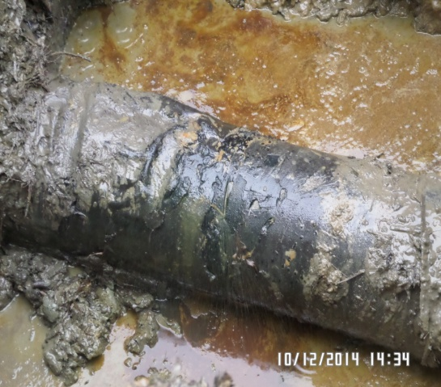
SPILL POINT (HACKSAW CUT)
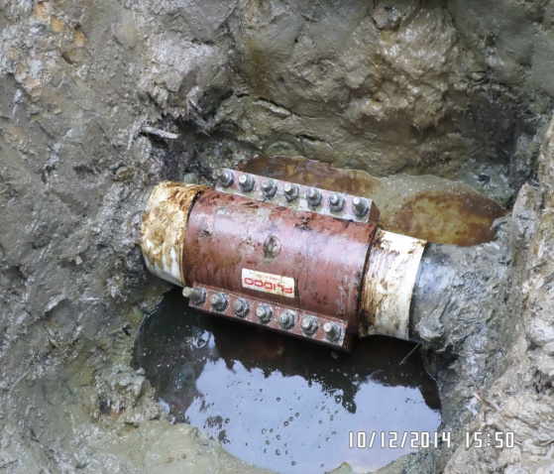
REPAIRED SPILL POINT

