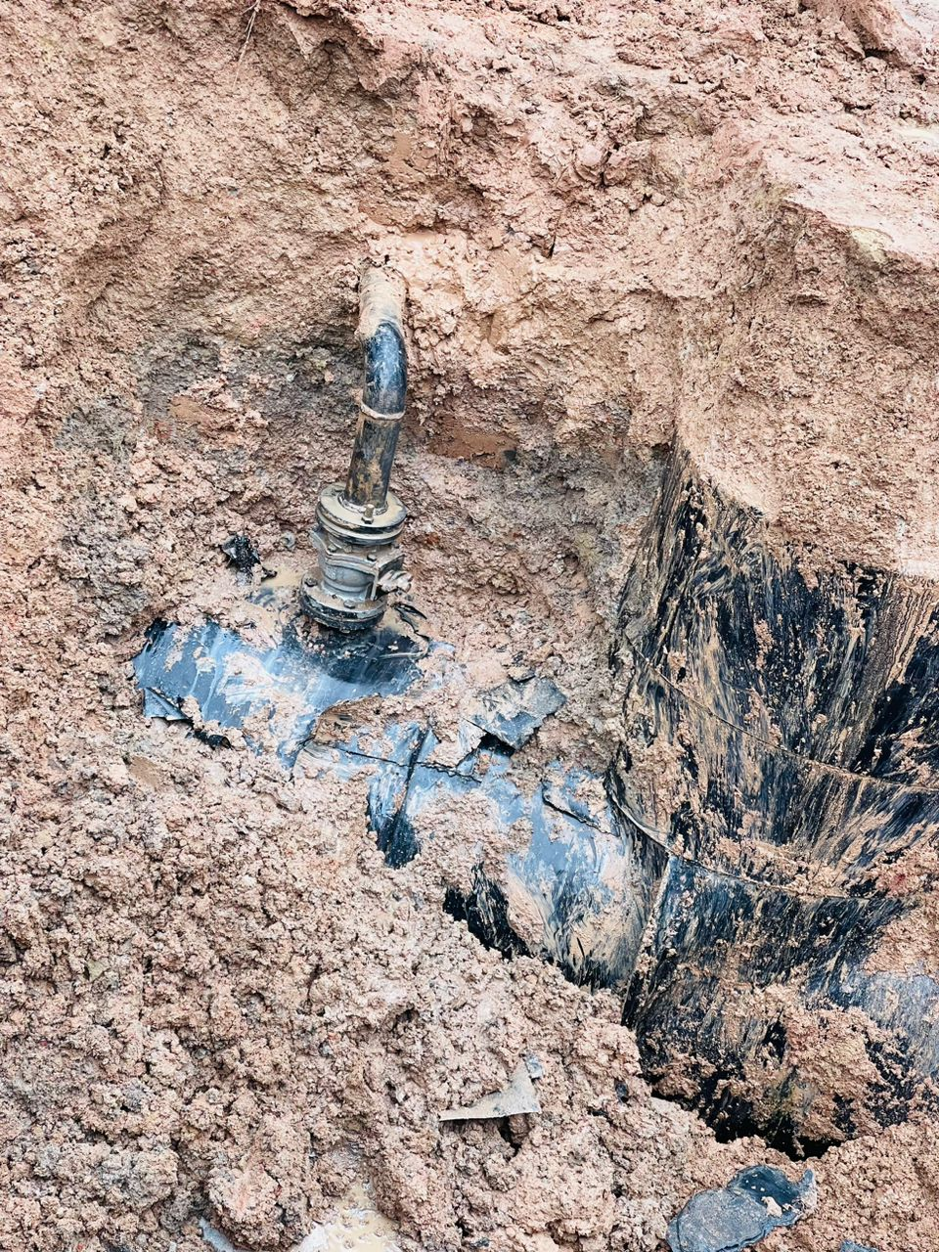
Figure 1. The spill point showing an illegal connection

