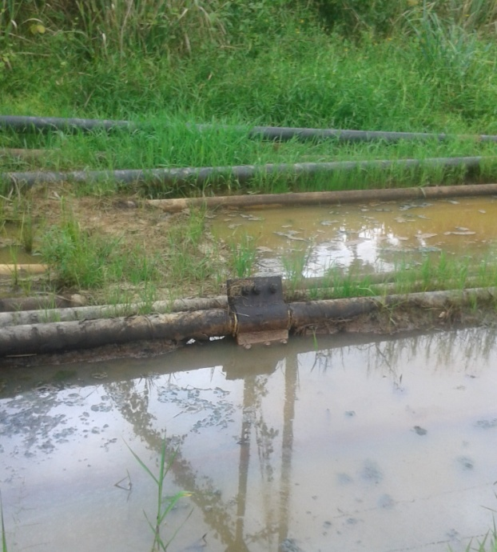
4’ylor Creek 1T F/L Akaraolu @ Oshie’

