- Picture of the spill point
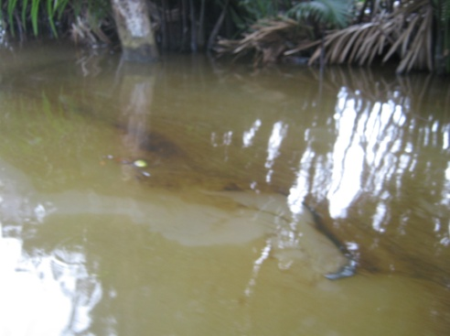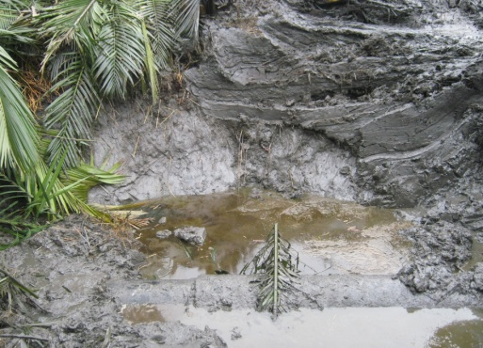
SPILL POINT BE/4 EXPOSED EXPOSED SPILL POINT

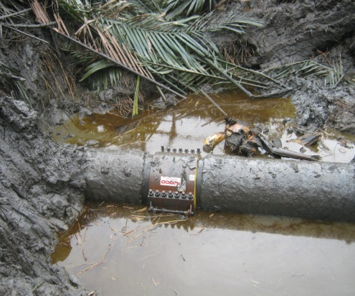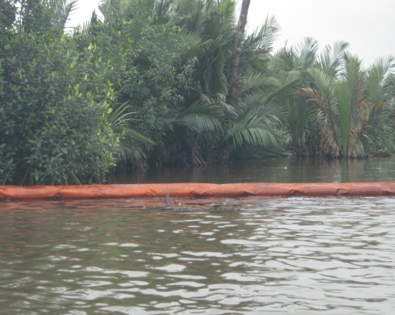
CLAMPED SPILL POINT CONTAINMENT MEASURE

