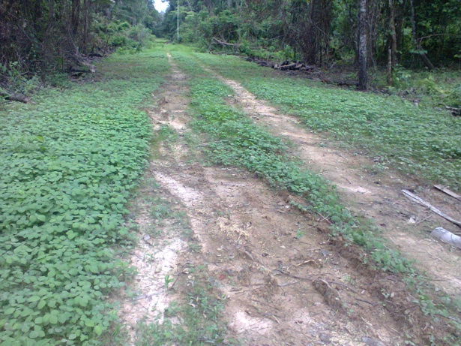
CLEAN UP SITE AT IKARAMA (2013_942728)

