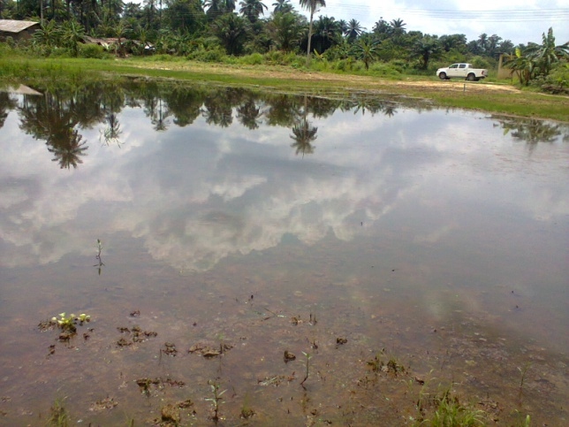
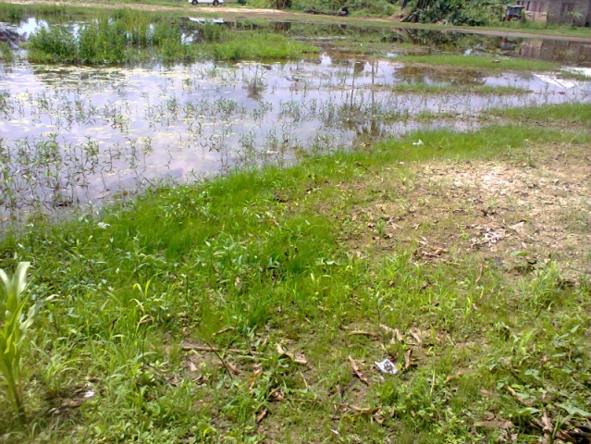
PICTURES SHOWING CLEANUP SITE AT IKARAMA (2013_987213)

