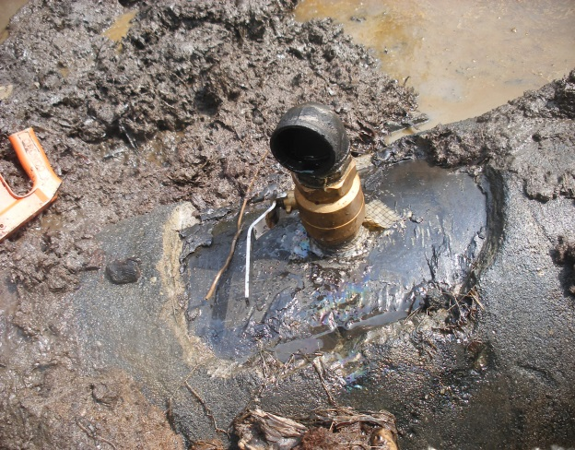 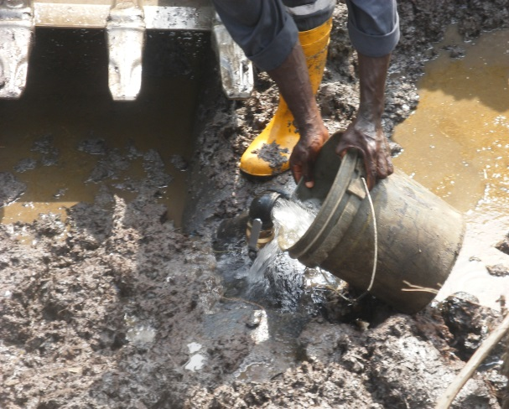 Fig. 1a 2” Nipple & Valve installed Fig.1b Point Spilling/discharging Water
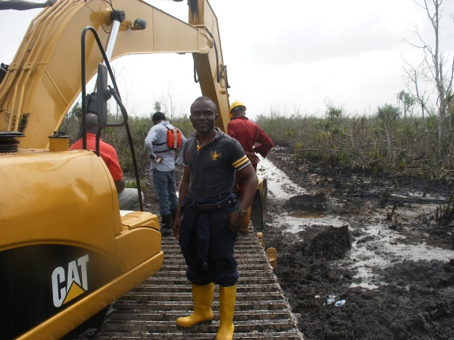 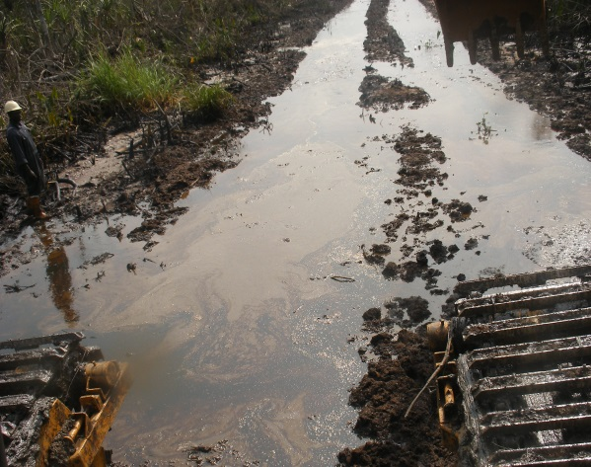 Fig. 2a Impacted Swamp/ Mangrove “Angala” Fig. 2b Pool of Crude Oil unrecovered
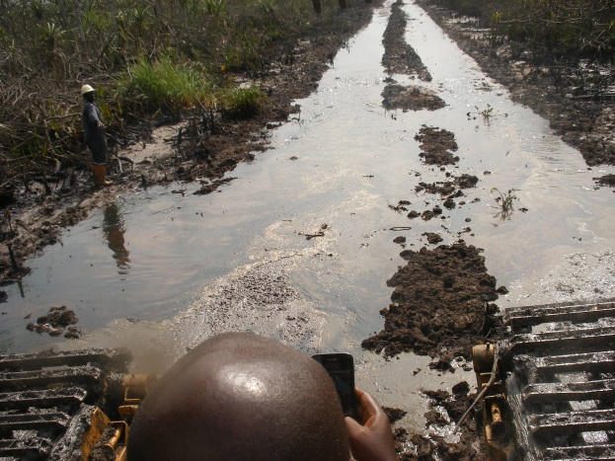 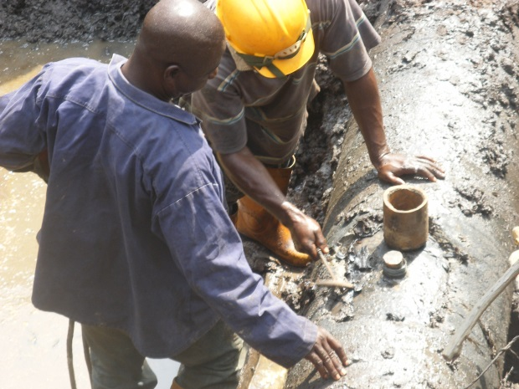 Fig. 3a Oyeregbene Creek Fig. 3b 3’’ Cone used for the repair
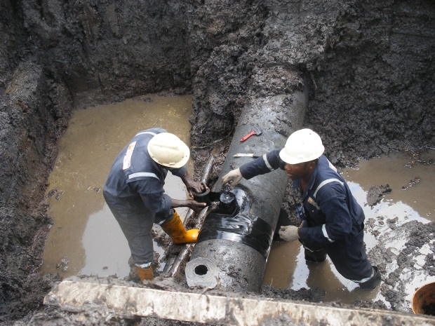 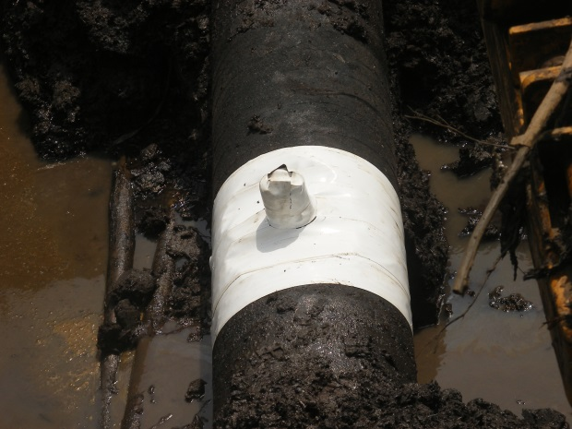 Fig. 4a 18’’ Pipe buried 4ft deep coated with tape Fig. 4b Repaired point lined with white tape

