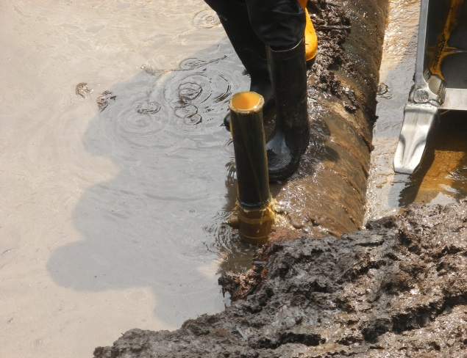 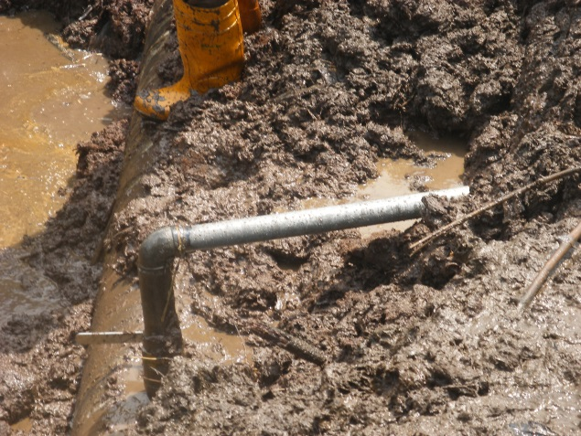 Fig. 1a 3’’ Nipple & Valve installed (SP. A) Fig.1b 3’’ Nipple and Valve with conectn (SP. B)
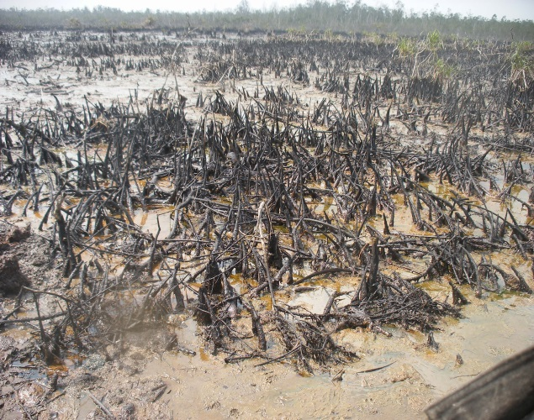 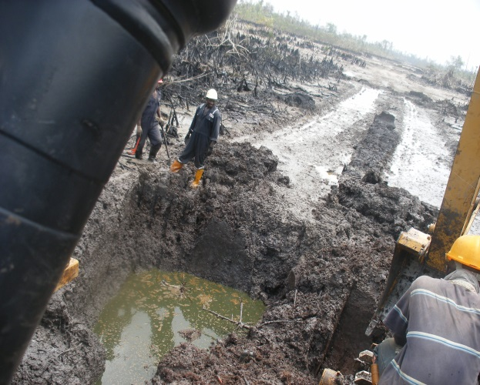 Fig. 2a Dead/Highly Impacted Mangrove “Angala” Fig. 2b Crude in Pit unrecovered along ROW
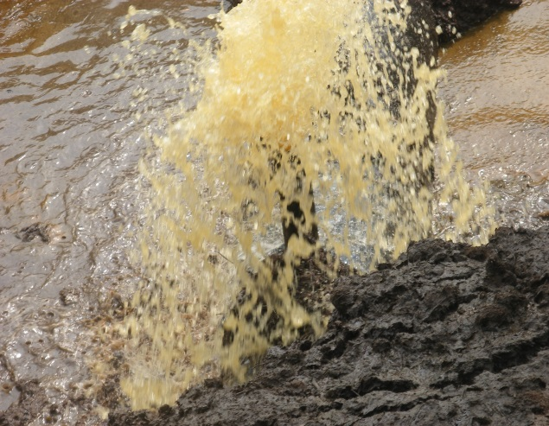 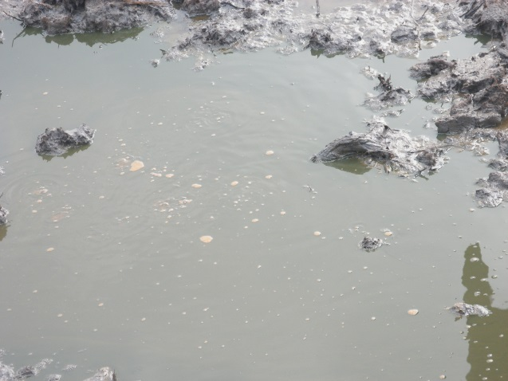 Fig. 3a Crude/Contaminated Water discharged Fig. 3b Crude Oil unrecovered
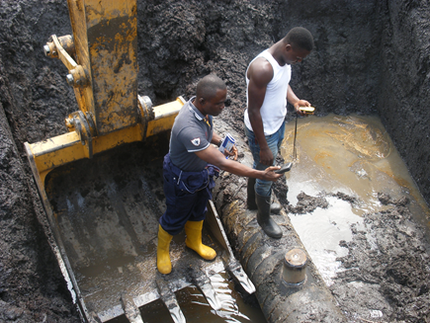 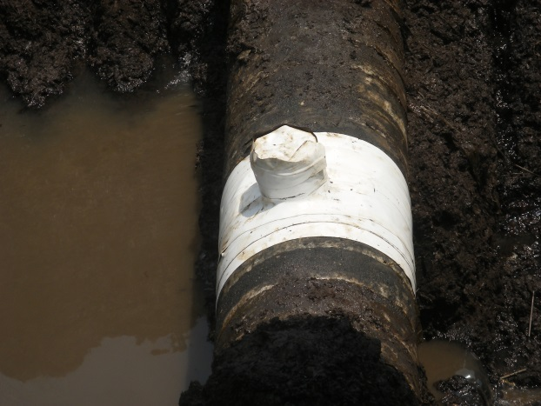 Fig. 4a 6’’ Cone used for the Repair Fig. 4b Repaired point lined with white tape

