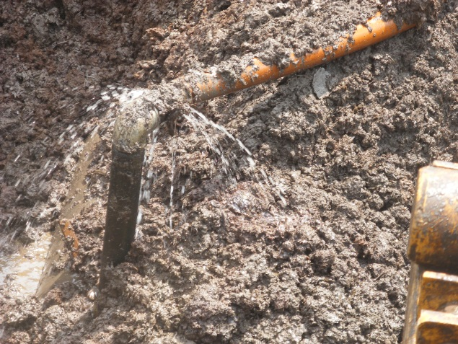 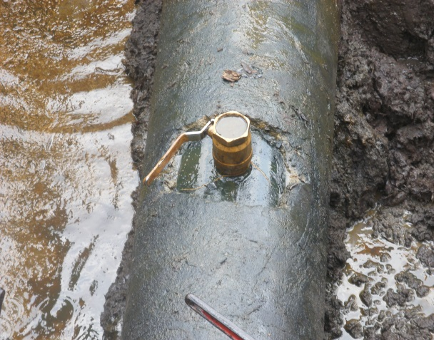 Fig. 1a 3’’ Nipple & Valve installed with a Hose Fig.1b 3’’ Nipple and Valve
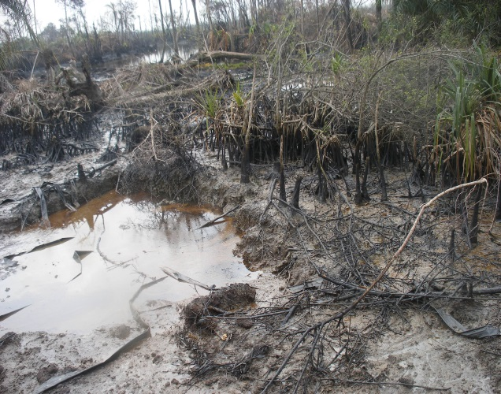 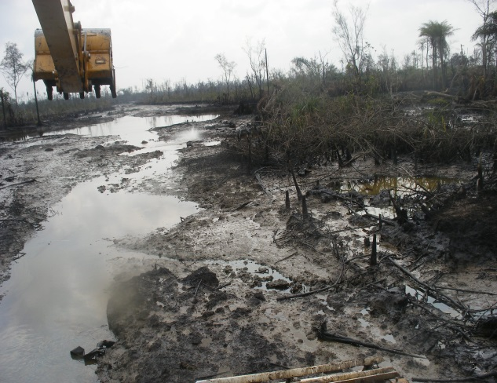 Fig. 2a Dead/Highly Impacted Mangrove “Angala” Fig. 2b Impacted Mangrove and NAOC ROW
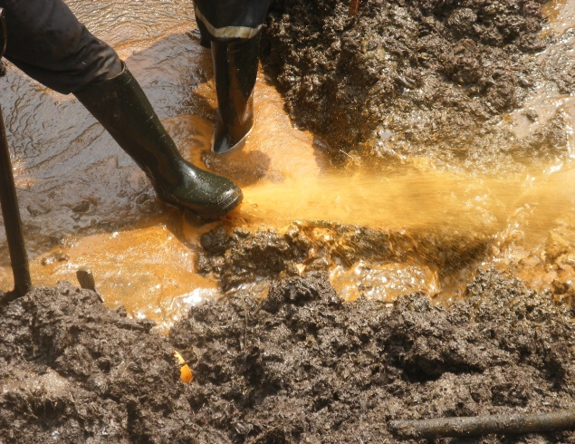 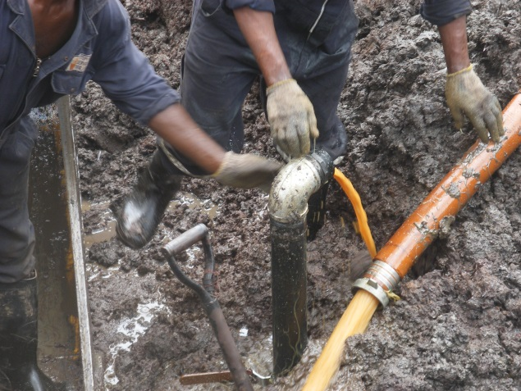 Fig. 3a 18’’ Pipe discharging Crude at High Pres. Fig. 3b Back flow of Crude - Hose removed
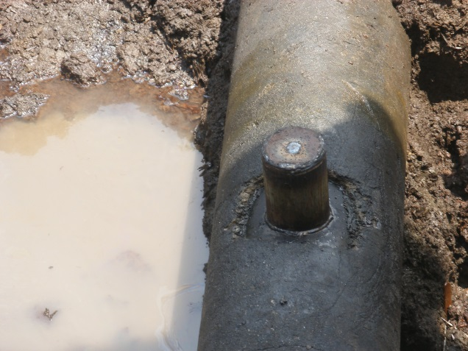 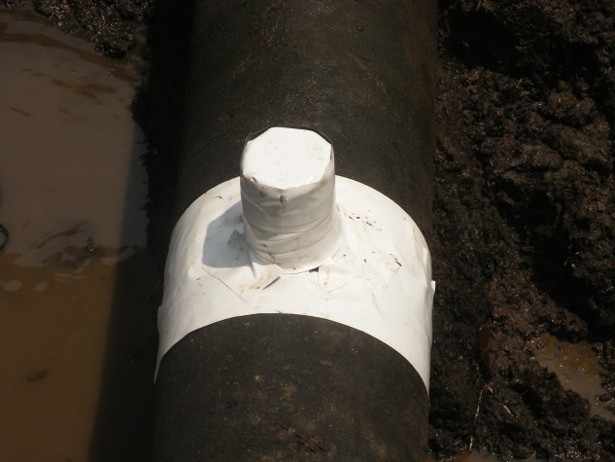 Fig. 4a 6’’ Cone used for the Repair Fig. 4b Repaired point lined with white tape

