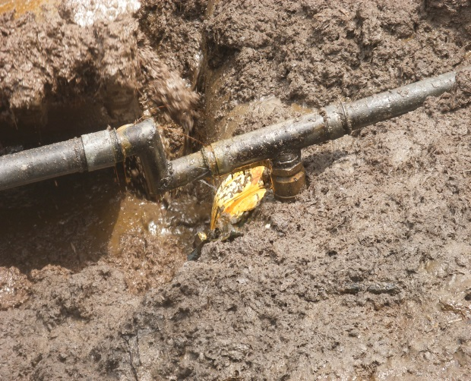 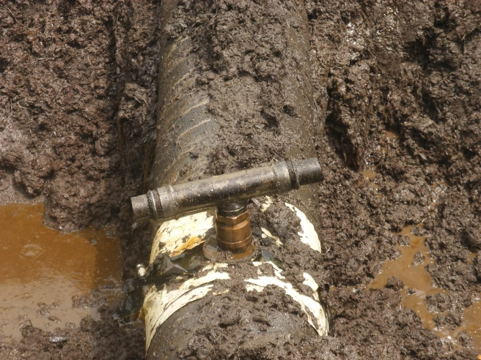 Fig. 1a 3’’ Nipple/Valve & T-Shaped Pipe installed Fig.1b 3’’ Pipe connected to Loading Points
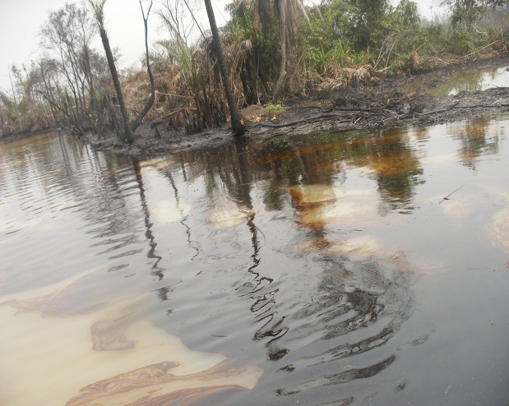 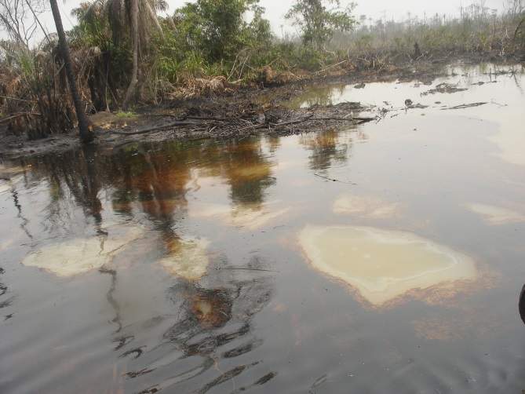 Fig. 2a Crude Oil floating on Tidal Water Fig. 2b Creek & Mangrove “Angala” Impacted
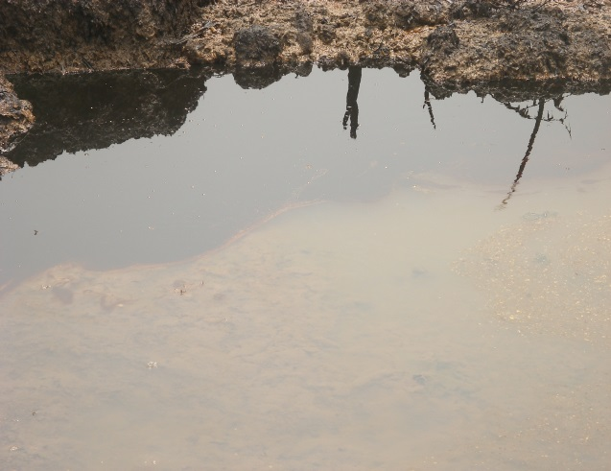 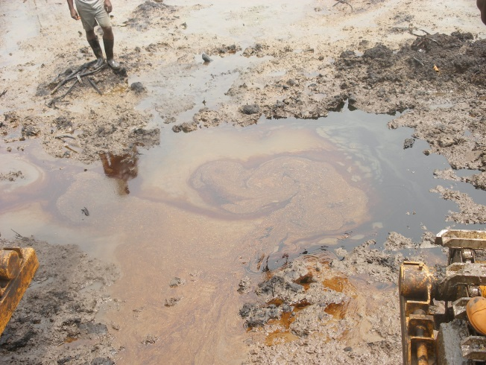 Fig. 3a Pool of Crude from Previous Spill. Fig. 3b Crude Sheen on Spill Point
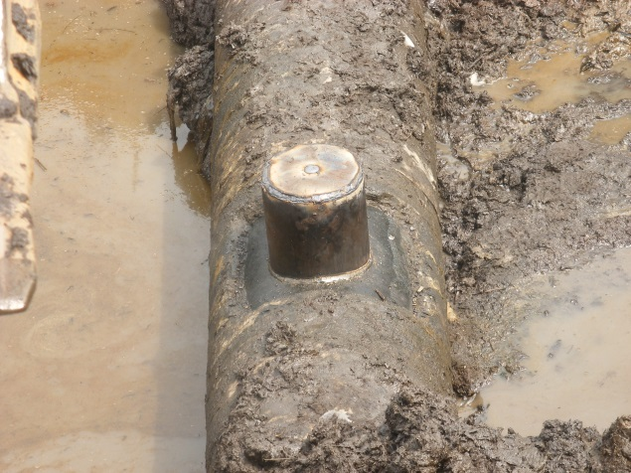 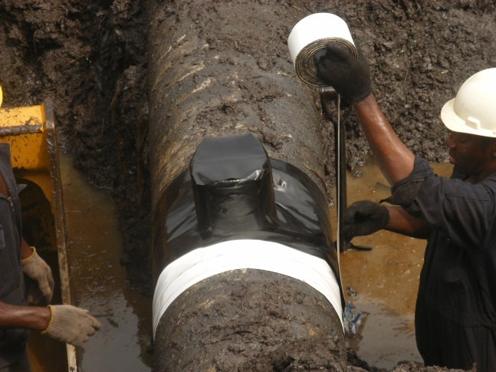 Fig. 4a 8” Cone used for the repair Fig. 4b 8” Cone raped with Tape.

