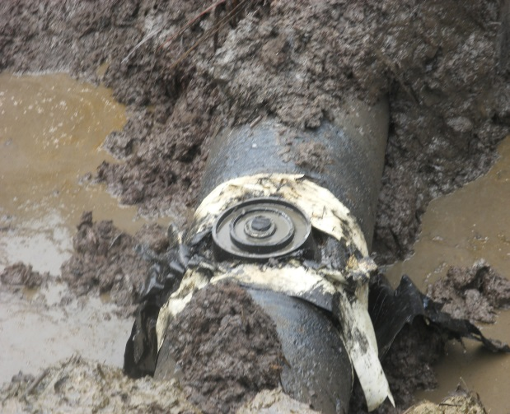 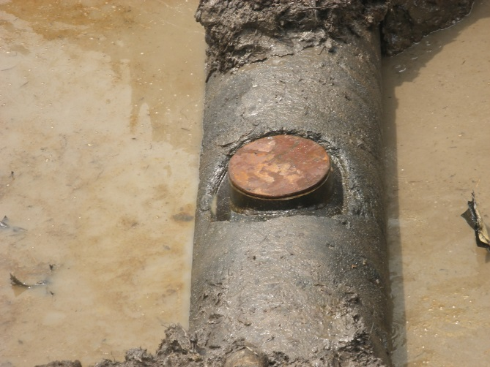 Fig. 1a Previously Repaired Point re-opened Fig.1b Spill Point
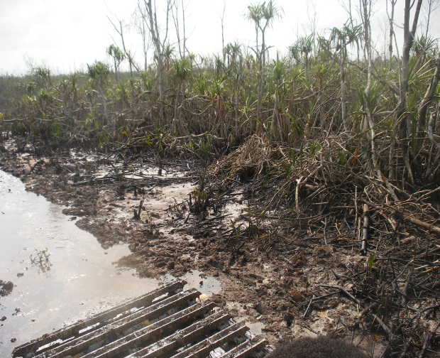 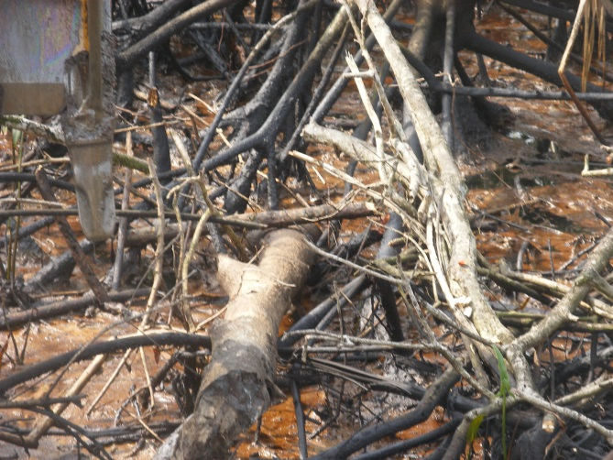 Fig. 2a Area badly impacted by previous Spill Fig. 2b Dead Mangrove “Angala” Impacted
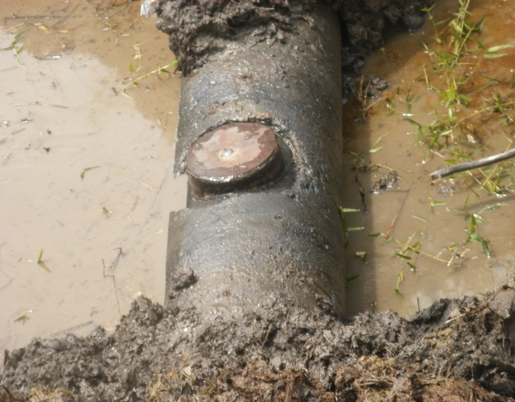 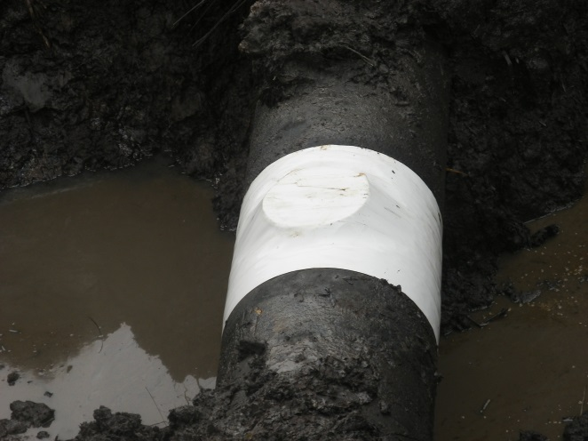 Fig. 3a 10” Cone used for the repair Fig. 3b 10” Cone raped with Tape.

