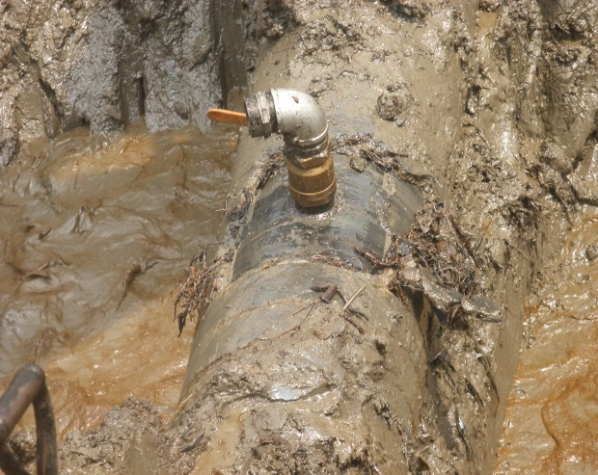 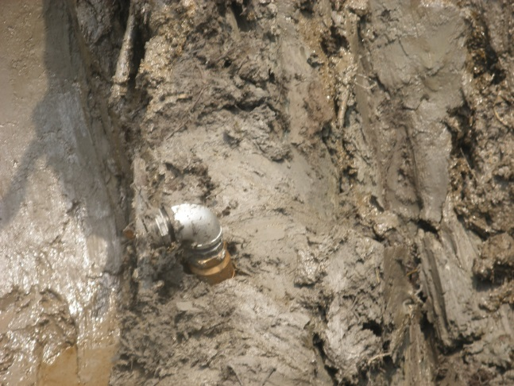 Fig. 1a 3’’ Nipple/Valve installed Fig.1b Silt – Clay Soil soaked with Crude Oil
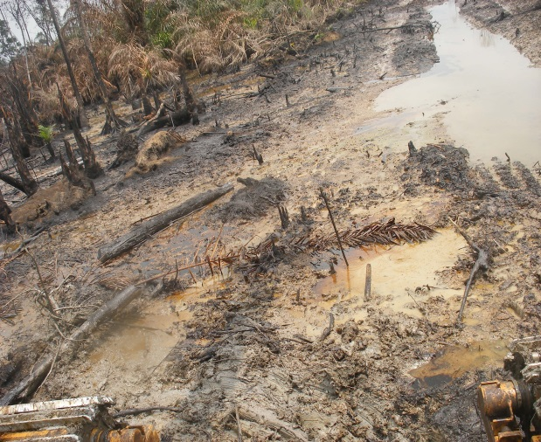 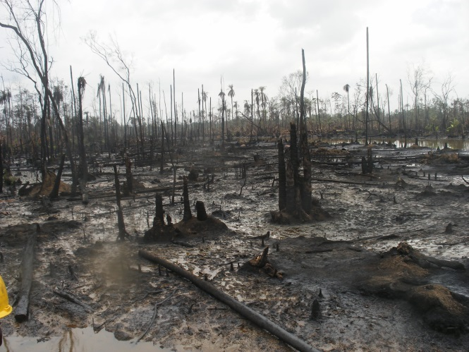 Fig. 2a Terrain highly impacted Fig. 2b Mangrove “Angala” destroyed
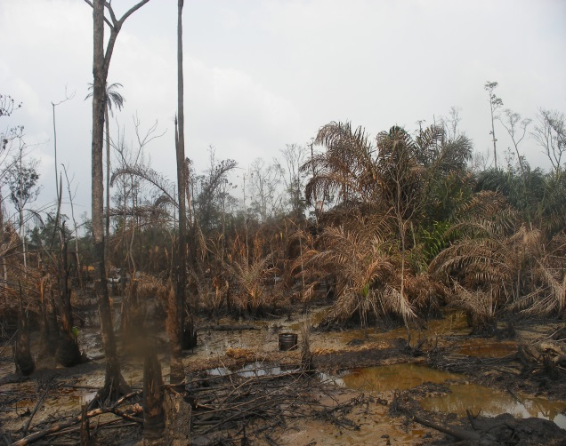 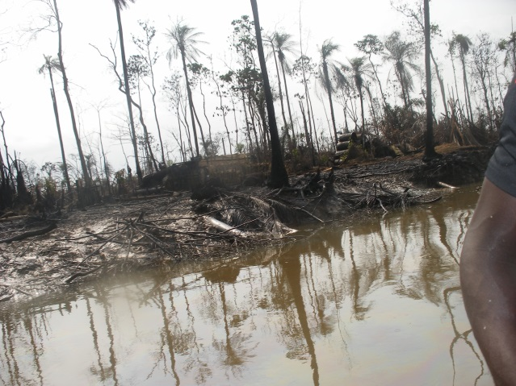 Fig. 3a Effect of Illegal Refining Activity. Fig. 3b Environment badly polluted
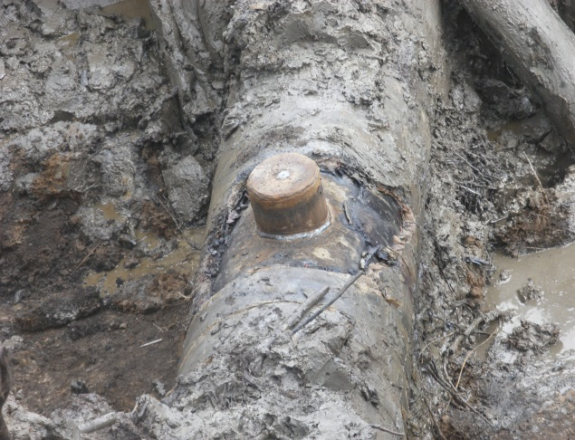 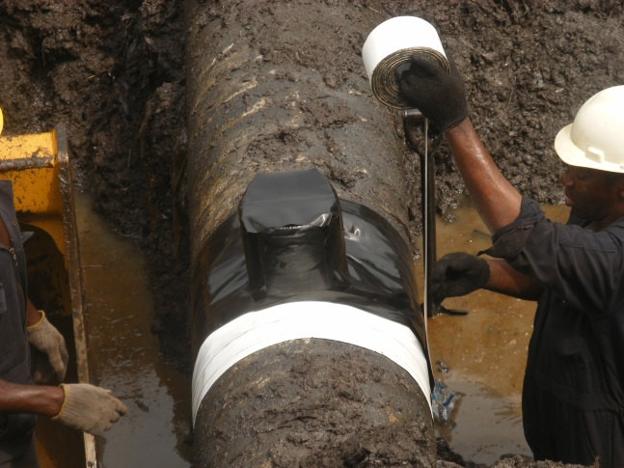 Fig. 4a 6” Cone used for the repair Fig. 4b 6” Cone raped with Tape.

