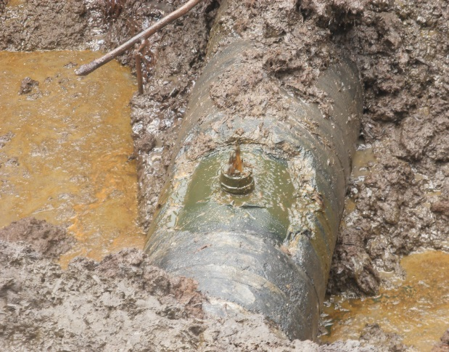 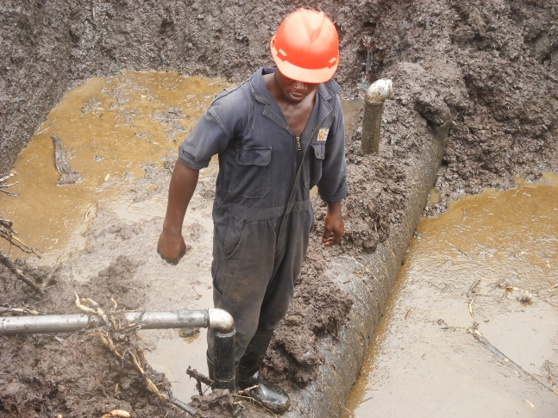 Fig. 1a 3’’ Nipple/Valve installed- Spill Point A Fig.1b 3’’ & 4’’ Nipple/Valves installed – B & C
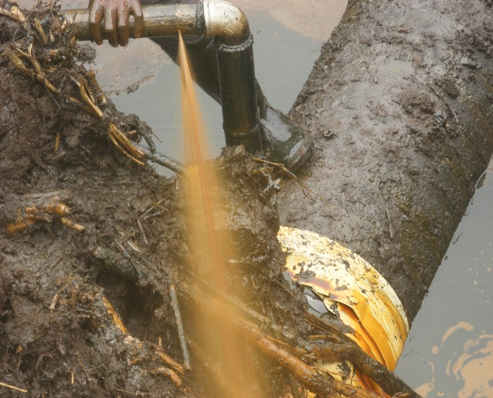 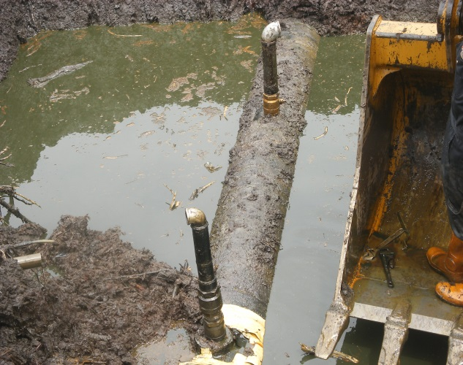 Fig. 2a Spill Point C discharging Crude Fig. 2b Pool of unrecovered Crude at SP. B & C
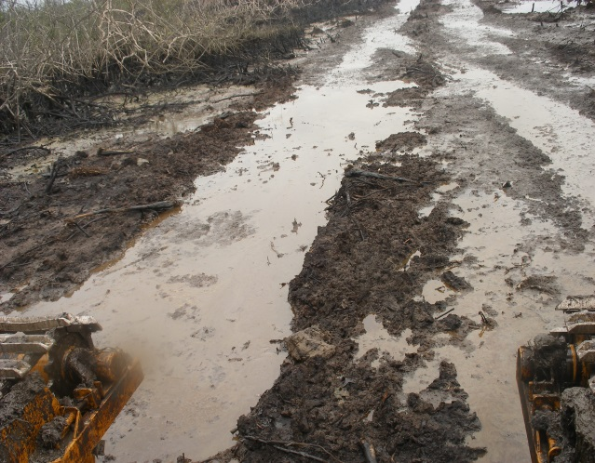 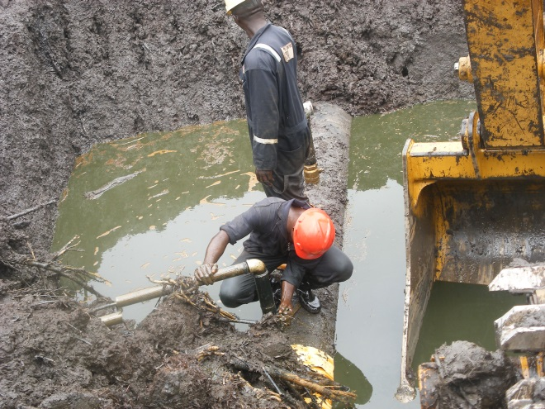 Fig. 3a Area badly impacted within/out of ROW Fig. 3b Dead Organic Matter/Soil soaked
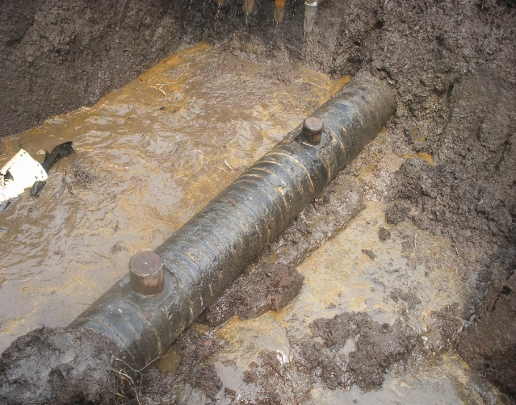 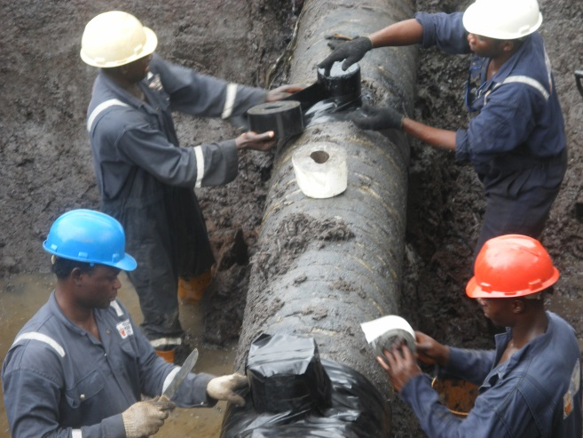 Fig. 4a 6” Cone used for the repair Fig. 4b 6” Cone raped with Tape.

