DOCUMENTATIONS/PHOTOGRAPHS;
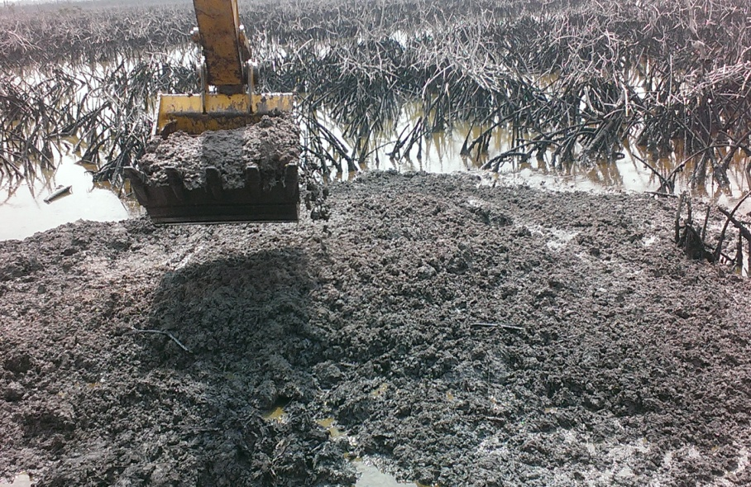
FIG 1 : OVERVIEW OF THE SITE
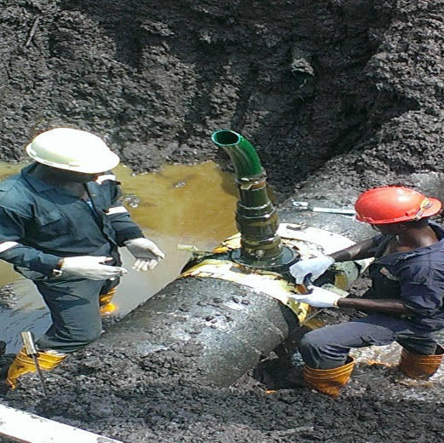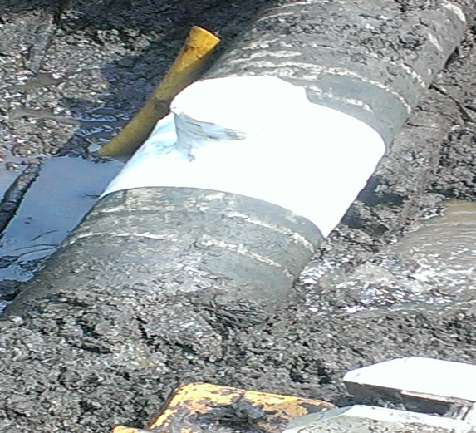
FIG 2: ILLEGAL BUNKERING POINT FIG 3: REPAIRED BUNKERING POINT

