DOCUMENTATIONS/PHOTOGRAPHS;
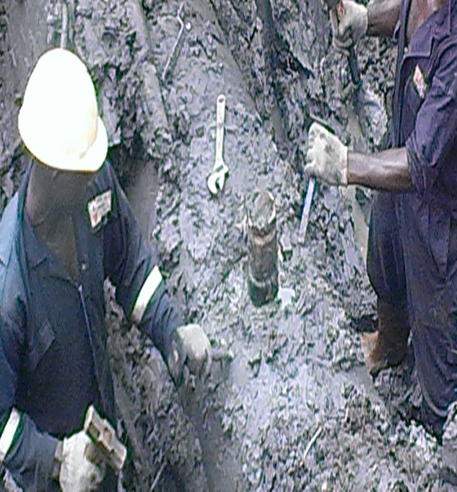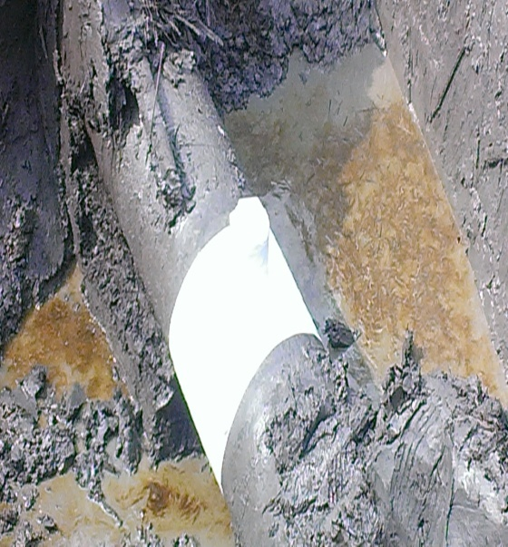
FIG 1: ILLEGAL BUNKERING POINT (B) FIG 2: REPAIRED POINT (B)

