DOCUMENTATIONS/PHOTOGRAHS;

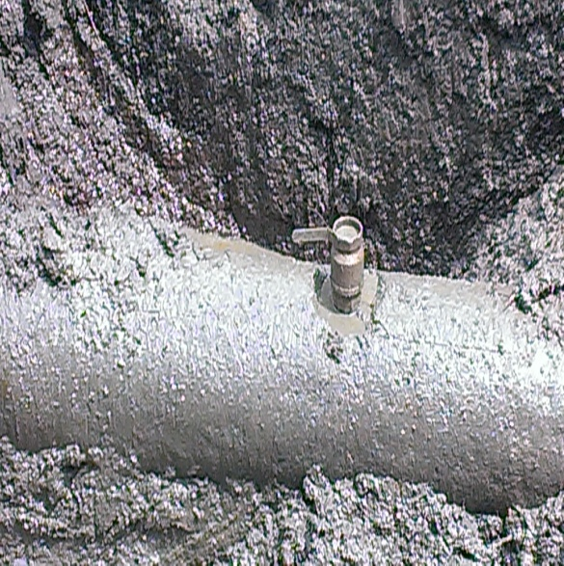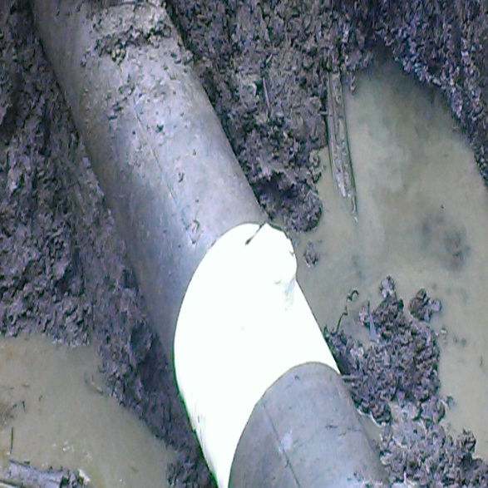
FIG 1: ILLEGAL BUNKERING POINT FIG 2: REPAIRED POINT

