DOCUMENTATIONS/PHOTOGRAPHS;
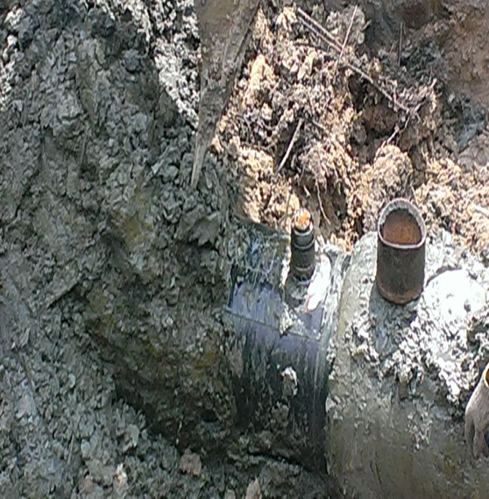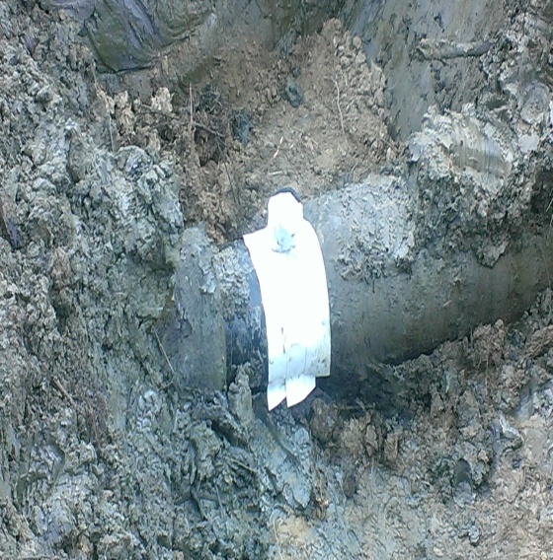
FIG 1: ILLEGAL BUNKERING POINT FIG 2: REPAIRED POINT

