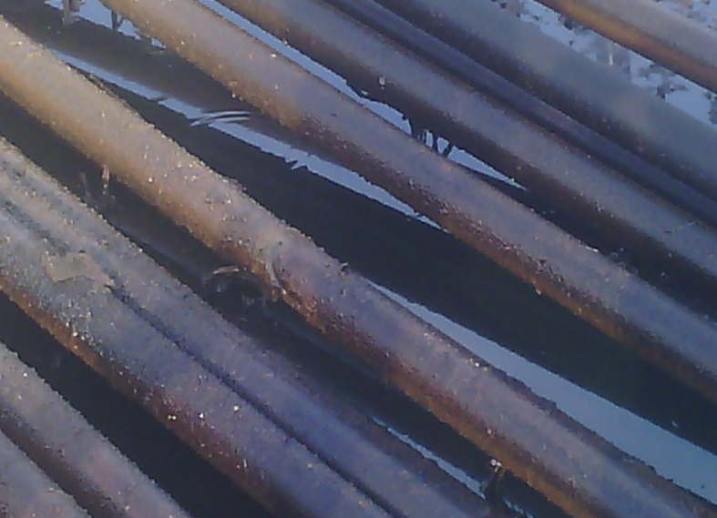

5MM drilled hole @ 11 o’clock on the facility
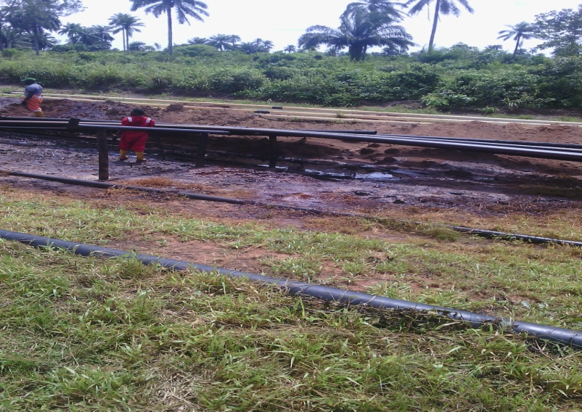
Area impacted by crude oil

