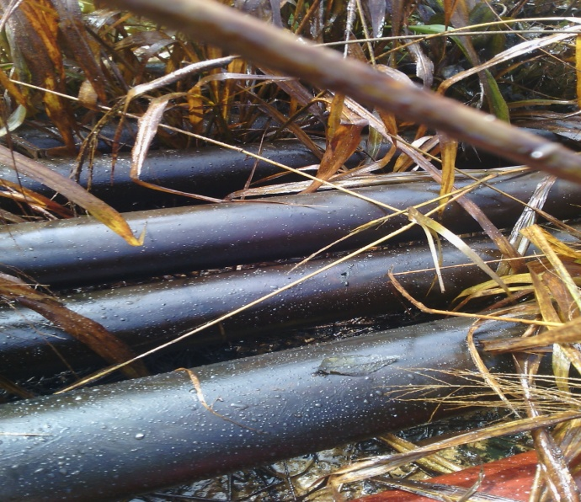

About 3mm drilled hole @ 12 o’clock position on the facility

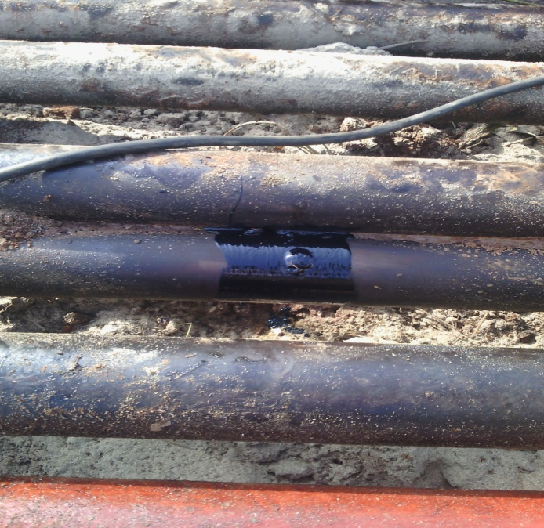

Facility after repair

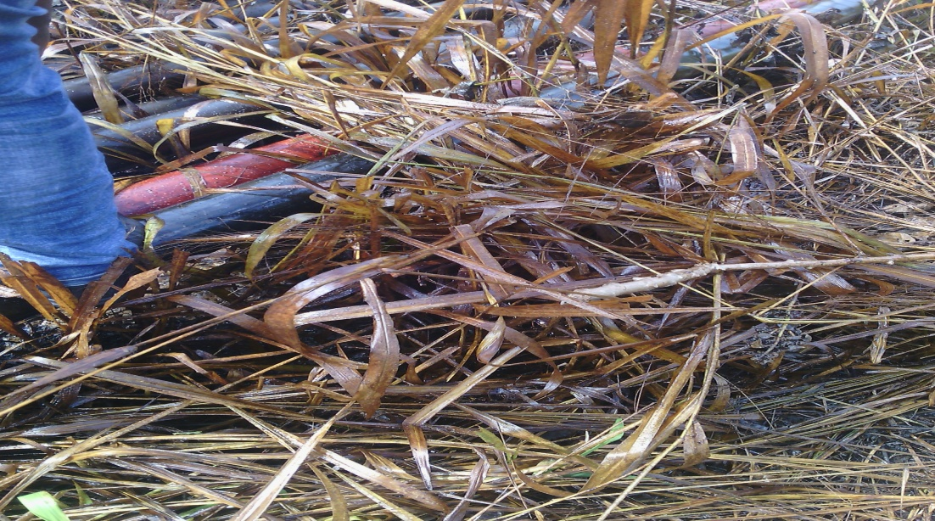
Area impacted by crude oil

