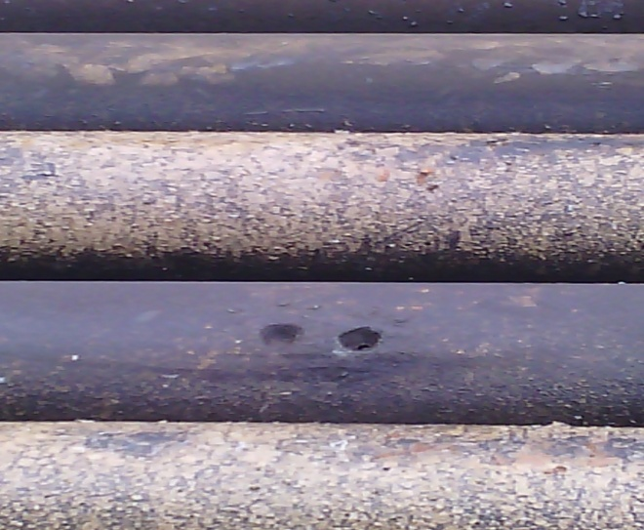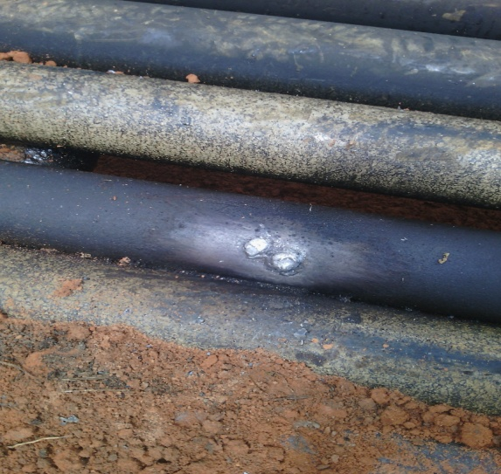
5mm DRILLED HOLE @ 11 ‘OCLOCK POINT AFTER REPAIR

