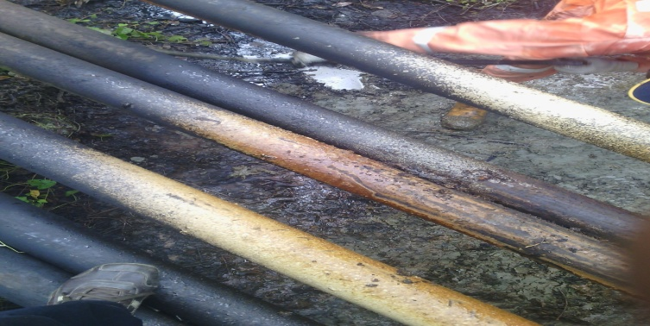

7mm hack saw cut was observed @ 9-11 o’ clock on the facility

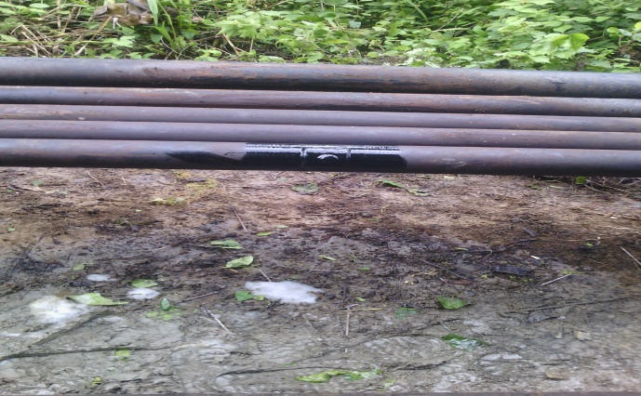
Point after repair

