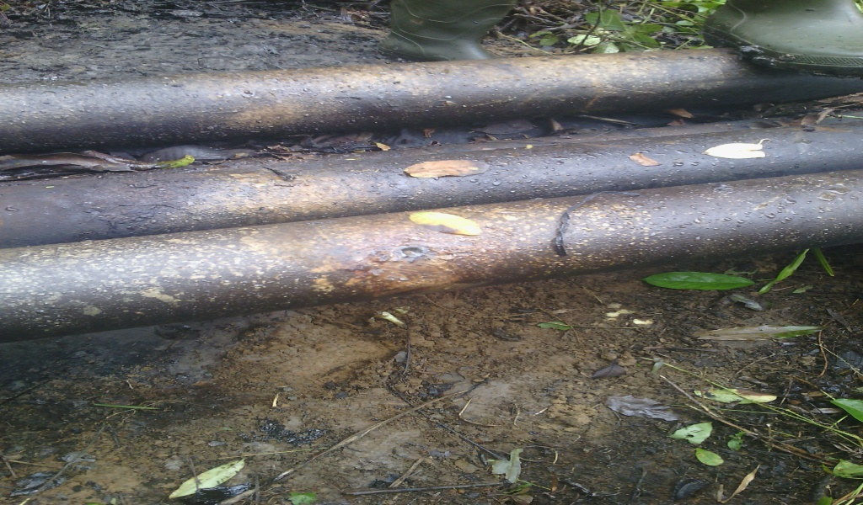
4mm drilled hole was observed @ 3 o’clock on the facility

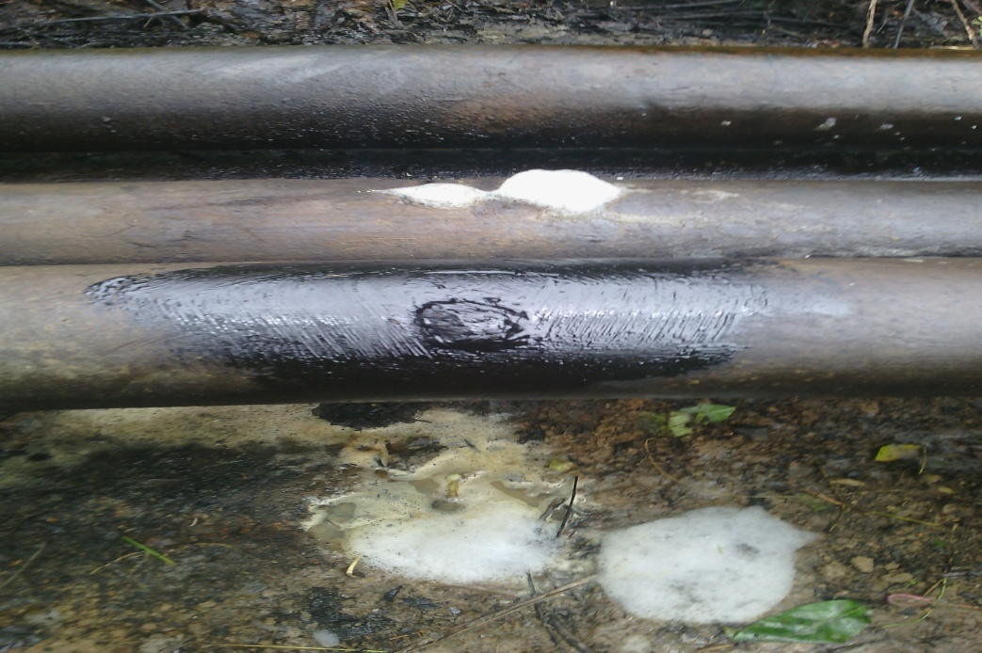
Point after repair

