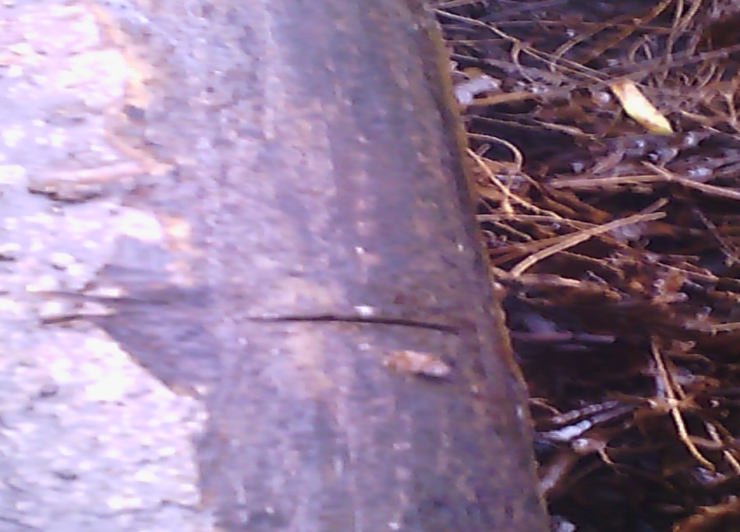

About 40mm hack saw cut was observed @1-2 o’clock position

