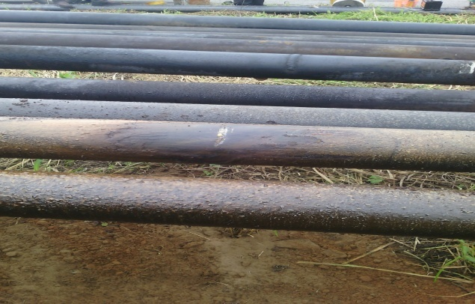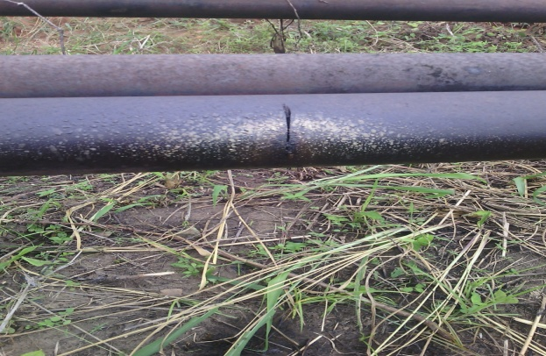

Two points (hack saw cuts 40mm each from 12-3 o’clock positions)

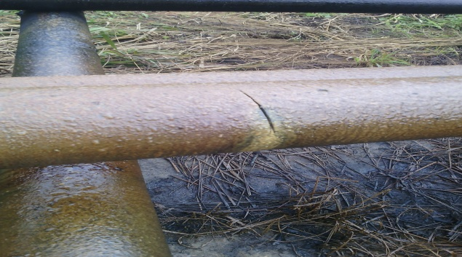

About 40mm hack saw cut @ 9-12 o’clock position on the facility.

