ZD,

Highlights of the Joint Investigation Visit at Spill Site on 18” Tebidaba / Brass Pipeline at Baberagbene Southern Ijaw L.G.A. Bayelsa State

INCIDENT NUMBER: 2015|SAR|024

INVESTIGATION TEAM

OLUSOLA ADENIYI NOSDRA
DAGANA J BYSMENV
IKHARO DAVIES NAOC, CRV

Date of Incident: 02/02/2015
Date First Reported:
Date of JIV: 02/02/2015

SITE DETAILS:

Spill Point Co-ordinates: N 04⁰ 53’ 29.4”, E006⁰ 21’ 46.5”
Area covered by spill:
Estimated Quantity Spilled: 35bbls
Material spilled: Crude Oil
Cause of Spill: Sabotage (Theft)
Quantity Recovered: Nil

OBSERVATIONS

- An unknown oersons cut off previously installed cone and installed 3”valve on the facility at 12 Oclock position for crude oil theft activities.

GENERAL COMMENTS

Legally refined crude is not easily accessible in the spill impacted environment
The JIV team arrived at the spill site at about 10:03hrs on the investigation day
Repair was done on site and JIV was conclusive.

Pictures Attached

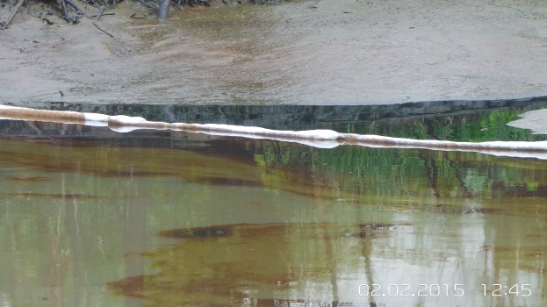
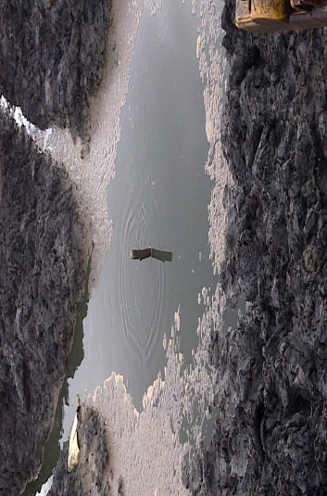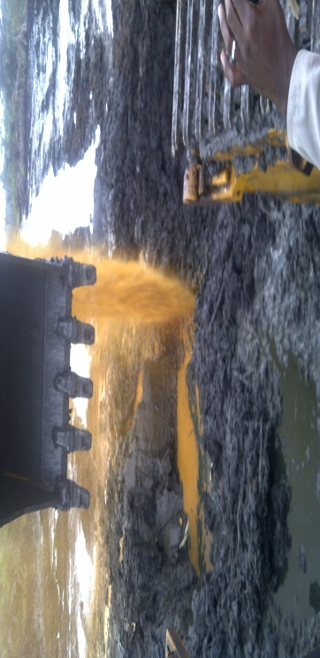

RECOMMENDATION

- NAOC should clean up and remediate the impacted area.
- NAOC should Increase surveillance of the facilities.
- NAOC should also introduce electronic surveillance on all facilities equipment.

CONCLUSION

- The spill was caused by third party interference for theft purposes
- JIV was completed.

ADENIYI OLUSOLA A

ESIl
25/02/2015

