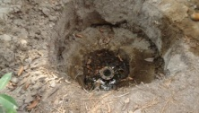
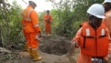
Fig. 2: 6'' illegal valve installed by third party on the 28'' pipeline facility
Fig. 1: 16m² ditch made by unknown persons

