ZD
REPORT ON JOINT INVESTIGATION VISIT TO SPDC 12’’ IMO RIVER – OGALI T/L @KOMKOM
- ATEENDANCE
NOSDRA Ikwen, Chris Agogo
RSMENV Atteng Claude ,C
SPDC Collins Ibe –HSE
SPDC Daniel Eyo – P/L
Community Frank Anyaso – (Youth PRO)

- SPILL DETIALS:
Date of spill 20th Oct 2015
Date of report 16th Nov 2015
Date of JIV 19TH/ 20TH Nov 2015
Location 12’’ Imo River-Ogali T/L @ KOMKOM
LGA Obigbo
State River State
Cause of spill Suspected non-leak crude oil theft
Impacted area Nil
Quantity spill Nil

- INTRODUCTION:
- A report of non-leak crude oil theft was reported to the Agency on 12” Imo River-Ogali T/L at Komkom on the 16th Nov 2015.
- The JIV Team visited the site on the 19th Nov 2015, but could not concluded the investigation. Therefore, it continued on the 20th Nov 2015.
- We were informed by the SPDC staff that they got information from the people handling remediation at the above site owing to previous incident, that sand bags were found in the soil during remediation.

- OBSERVATION:
- And upon excavation, sand bags numbering about ten in number were actually seen, and when the site was further dug to the pipeline, two previous clamps were seen and intact.
- We concluded that the sand bags may have been left-over from the previous incident. Hence the clamps from the previous repairs were still intact.
- There wasn’t any impacted sight, hance no spill was recorded.
- Attached are photos of the sight visited.
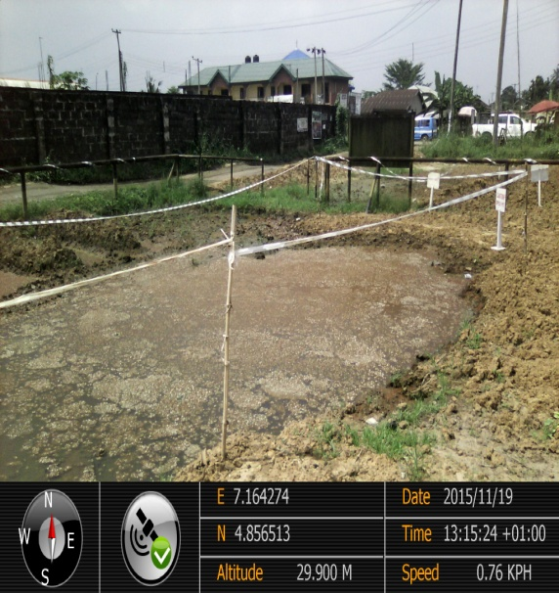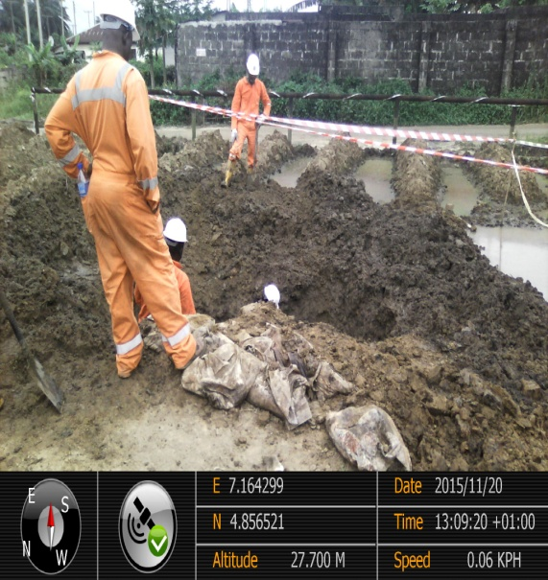
Figure 1. Suspected spill point Figure 2.suspected spill area been dug out.

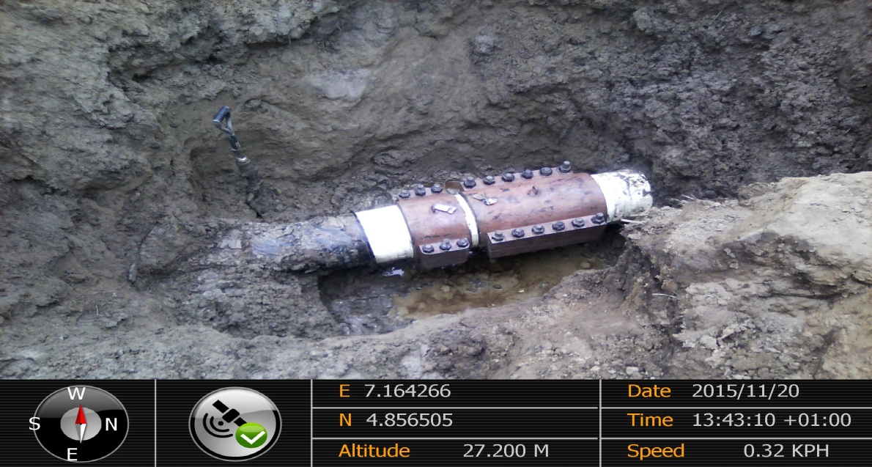
Figure 3. Two previous clamps well fitted.

Sign_______________
Ikwen, Chris Agogo ES1

ZD
REPORT ON JOINT INVESTIGATION VISIT TO SPDC 6’’ OBIGBO NORTH- NEW IBUBU M/F AT OGALI
- ATEENDANCE
NOSDRA Ikwen, Chris Agogo
RSMENV Atteng Claude ,C
SPDC Okoye, Emeka – P/L
SPDC Erhabor Nosa
Community Nhawala Dandyson – (CDC)

- SPILL DETIALS:
Date of spill 20th Oct 2015
Date of report 17th Nov 2015
Date of JIV 21TH/ 20TH Nov 2015
Location 6’’ Obigbo Northr-New Inubu M/F @ Ogali
LGA Eleme
State River State
Cause of spill Suspected non-leak crude oil theft
Impacted area Nil
Quantity spill Nil

- INTRODUCTION:
- A report of non-leak crude oil theft was reported to the Agency on 6” Obigbo north-New Ibubu M/F @ Ogali on the 17th Nov 2015.
- The JIV Team visited the site on the 21th Nov 2015, and started the investigation at about 13:30 hours and concluded at about 14:40 hours.

- OBSERVATION:
- 1” valve was seen on the surface of the soil, and upon excavation, 1’’niple valve was also seen fitted to a locally fabricated clamp drilled into the pipeline.
- There wasn’t any fresh soil or spills around the suspected area, hence it was an old incedent.
- Repair work was carried out and clamped.
- There wasn’t any impacted sight, hance no spill was recorded.
- Attached are photos of the sight visited.

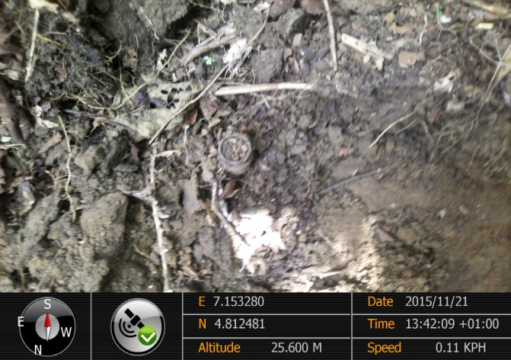
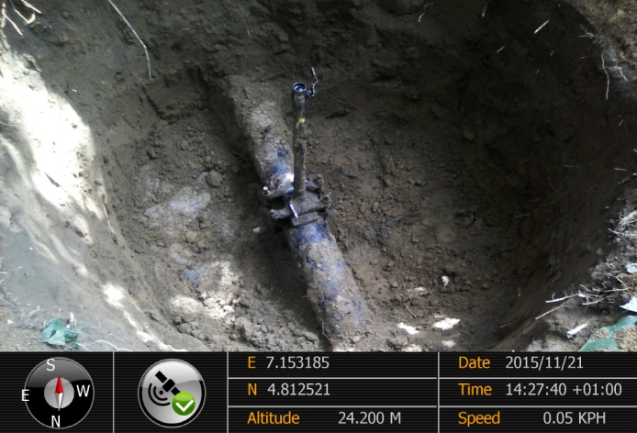
Figure 1. 6” valve on the top surface of the soil.
Figure 2. A 6” nipple valve fitted to the pipeline

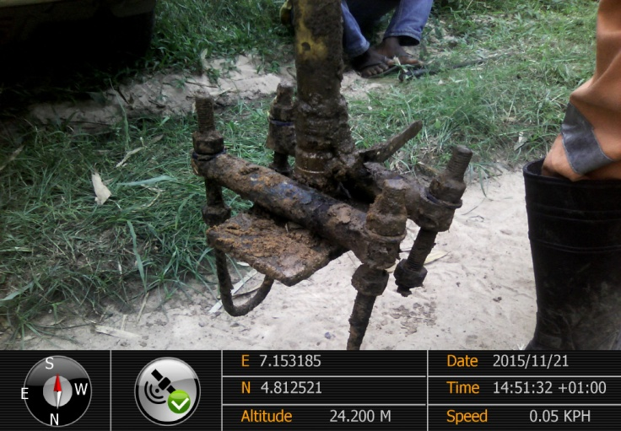
Figure 3 . A locally fabricated clamp

Sign__________________________
Ikwen, Christioher Agogo ES1

