PHOTOGRAPH:
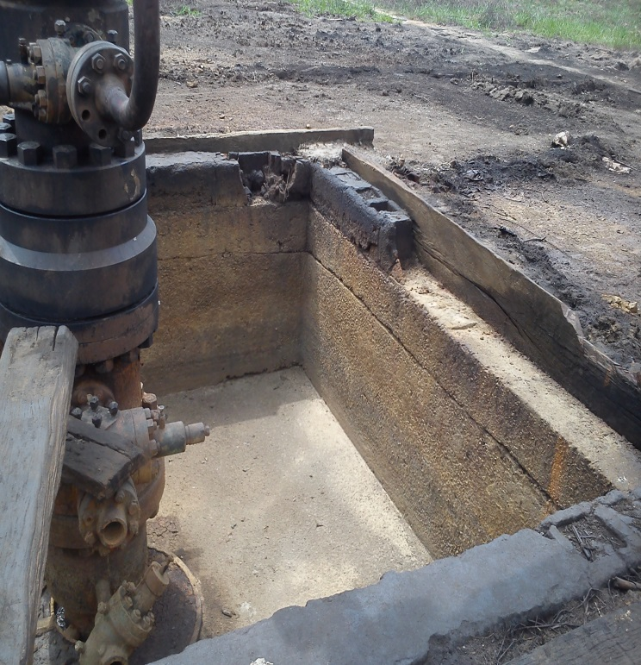
Loosed bolts and nuts
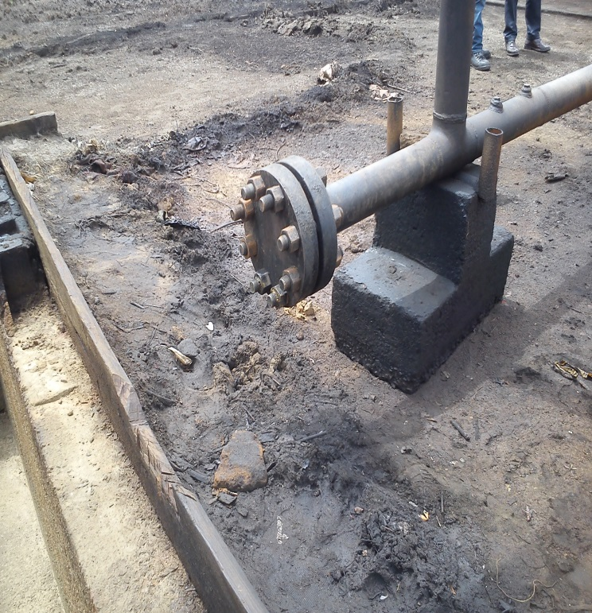
Loosed bolts and nuts on the flange of wellhead

